📘 Two-Dimensional Array (2D Array)
🧠 CORE POINT (Memorize This)
👉 A 2D array in Java is accessed using two indexes because it has two levels of indexing.
That’s the heart of the concept.

🔍 Explain the Core Point (Slow & Clear)
What does “two levels of indexing” mean?
• A 2D array does not store values directly at the first level.
• The first level stores references to other arrays.
• The second level stores the actual values.
That is why two indexes are required.

🧩 How indexing works (Step-by-step thinking)
int[][] arr = new int[3][5];
Step 1: First index
arr[0]
• This does not give a number
• It gives an inner array
So:
👉 First index → selects which array

Step 2: Second index
arr[0][2]
• Now we go inside that selected array
• This gives the actual value
So:
👉 Second index → selects value inside the array

🔑 Why it is called “Two-Dimensional”
• One index is not enough
• We need:
- One index to choose the inner array
- One index to choose the value inside it
📌 Two indexes = Two dimensions

🧠 One-Line Memory Hook (Very Strong)
👉 First index chooses the array, second index chooses the value.
Remember this line — it will never fail you.

❌ What NOT to remember (to avoid confusion)
❌ Rows and columns
❌ Tables and matrices
These are only visual help, not the real reason.

✅ Final Perfect Definition (Exam + Interview Safe)
👉 A 2D array in Java is an array that stores references to other arrays, so two indexes are needed—one to select the inner array and one to select the value inside it.
2️⃣ Syntax in Java (Core Idea First)
🧠 CORE IDEA
👉 A 2D array has two sizes because it has two levels.
Now apply this idea to the syntax.
int[][] arr = new int[3][5];
What does this really mean?
• 3 → how many inner arrays we want
• 5 → how many values each inner array can store
📌 So this tells Java:
- Create 3 separate arrays
- Each array can store 5 integers
Memory meaning (important to remember)
👉 It does NOT mean:
- One table of 15 values
👉 It DOES mean:
- 3 arrays × 5 values each

3️⃣ How 2D Array is Stored in Memory (Very Important)
🧠 CORE IDEA
👉 A 2D array is created in two steps in heap memory.

Stack Memory (Simple Rule)
• Stack stores only the reference variable
• arr is just a name that points to heap
arr → heap

Heap Memory (Step-by-Step Creation)
Step 1: Outer array is created
• Java creates one array of size 3
• This array stores 3 references, not values
Think like this:
👉 Outer array = list of addresses

Step 2: Inner arrays are created
• Each reference points to a separate inner array
• Each inner array has 5 integer slots
So heap memory looks like:
arr (stack)
↓
Heap:
Index 0 → [ ] [ ] [ ] [ ] [ ]
Index 1 → [ ] [ ] [ ] [ ] [ ]
Index 2 → [ ] [ ] [ ] [ ] [ ]

📌 Important Points to Lock in Memory
✔️ Inner arrays are independent objects
✔️ Java does not store 2D arrays as one big block
✔️ Each inner array lives separately in heap

4️⃣ Example Usage (Understand Indexing Clearly)
arr[0][2] = 50;
How Java reads this:
1️⃣ arr[0]
→ select the inner array at index 0
2️⃣ arr[0][2]
→ select position 2 inside that array
3️⃣ = 50
→ store value 50
In very simple words:
• Group = 0
• Position = 2
• Value = 50

5️⃣ When Should We Use a 2D Array?
🧠 CORE IDEA
👉 Use a 2D array when data has two levels of grouping.
Examples:
• Classes → Students
• Departments → Employees
• Cities → Areas
• Rows → Columns
If data needs:
- One index → 1D array
- Two indexes → 2D array

⚠️ Small but Very Important Clarification
❌ Wrong thinking
A 2D array is a table in memory
✅ Correct thinking
A 2D array is an array that stores references to other arrays
That is why:
• Rows can have different sizes
• Java allows this:
int[][] arr = new int[3][];
arr[0] = new int[2];
arr[1] = new int[5];
arr[2] = new int[1];
Each inner array:
✔️ Is created separately
✔️ Can have different length

🧠 One-Line Gold Summary (Memorize This)
👉 A 2D array in Java is an array that stores references to other arrays, so each inner array is a separate object in heap memory.

📘 Memory Representation of 2D Array in Java
Example:
int[][] arr = new int[3][5];
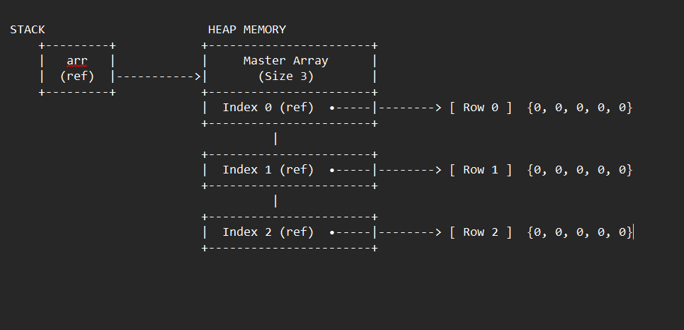

🧠 Core Idea (Must Remember)
👉 A 2D array in Java is not a single block of memory.
👉 It is one outer array that stores references to multiple inner arrays.
This memory map shows that clearly.

1️⃣ Stack Memory (Left Side)
• Stack contains only the reference variable arr.
• arr does not store data.
• arr only points to an array object in heap.
📌 In the diagram:
STACK ( if arr is a local variable, the memory for ref is stored based on type of variable)
arr (ref)
✔️ This is correct because arr is a local variable.

2️⃣ Heap Memory – Outer Array (Master Array)
• Heap stores the actual array objects.
• First, Java creates one outer array of size 3.
📌 In the diagram:
Master Array (Size 3)
• This outer array does not store integers.
• It stores 3 reference slots:
- Index 0 (ref)
- Index 1 (ref)
- Index 2 (ref)
👉 Each slot can point to an inner array.

3️⃣ Heap Memory – Inner Arrays (Rows)
• After creating the outer array, Java creates 3 inner arrays.
• Each inner array has 5 integer elements.
📌 In the diagram:
Index 0 (ref) → [ Row 0 ] {0, 0, 0, 0, 0}
Index 1 (ref) → [ Row 1 ] {0, 0, 0, 0, 0}
Index 2 (ref) → [ Row 2 ] {0, 0, 0, 0, 0}
✔️ Each row is a separate array object in heap.
✔️ All values are 0 by default (because int default value is 0).

4️⃣ Important JVM Observations (Very Important)
🔹 Default Values
• All int elements are initialized to 0.
• This happens automatically by JVM.

🔹 Separate Objects
• Each row is a different array object.
• Rows are not stored together as one big block.
👉 This is why Java supports jagged arrays.

🔹 Two-Level Structure
• First level → references (outer array)
• Second level → actual data (inner arrays)
This is why two indexes are needed:
arr[rowIndex][columnIndex]

5️⃣ How Access Works (From This Memory Map)
Example:
arr[1][3] = 50;
Step-by-step:
1️⃣ arr[1] → go to Index 1 reference
2️⃣ Follow that reference to Row 1 array
3️⃣ [3] → go to index 3 in Row 1
4️⃣ Store value 50

6️⃣ Why This Is NOT a True Table
❌ Java does NOT store 2D arrays like a table or matrix
✅ Java stores them as array of array references
That is why this is valid:
int[][] arr = new int[3][];
arr[0] = new int[2];
arr[1] = new int[5];
arr[2] = new int[1];

🧠 One-Line Gold Note (Write Below Diagram)
👉 In Java, a 2D array is implemented as one outer array of references pointing to multiple inner array objects stored separately in heap memory.

📘 Three-Dimensional Array (3D Array)

🧠 CORE POINT (Memorize This)
👉 A 3D array in Java is accessed using three indexes because it has three levels of indexing.
This is the heart of the concept.
If you remember this, everything else becomes easy.

🔍 Explain the Core Point (Slow & Clear)
What does “three levels of indexing” mean?
• A 3D array does not store values directly at the first level.
• The first level stores references to 2D arrays.
• The second level stores references to 1D arrays.
• The third level stores the actual values.
📌 That is why three indexes are required.

🧩 How Indexing Works (Step-by-Step Thinking)
Example:
int[][][] arr = new int[3][4][3];

Step 1️⃣: First index
arr[0]
• This does not give values
• It gives a 2D array
So:
👉 First index → selects which 2D array

Step 2️⃣: Second index
arr[0][1]
• This does not give a value
• It gives a 1D array
So:
👉 Second index → selects which 1D array

Step 3️⃣: Third index
arr[0][1][2]
• Now we are inside the 1D array
• This gives the actual value
So:
👉 Third index → selects the value

🔑 Why it is called “Three-Dimensional”
• One index is not enough
• Two indexes are not enough
• We need:
- One index to choose the 2D array
- One index to choose the 1D array
- One index to choose the value
📌 Three indexes = Three dimensions

🧠 One-Line Memory Hook (Very Strong)
👉 First index chooses the 2D array, second index chooses the 1D array, third index chooses the value.
If you remember this line, you will never get confused.

❌ What NOT to Remember (Avoid Confusion)
❌ Boxes, tables, cubes
❌ Physical shapes
These are only visual help, not the real reason.

✅ Final Perfect Definition (Exam + Interview Safe)
👉 A 3D array in Java is an array that stores references to 2D arrays, which store references to 1D arrays, so three indexes are required to reach the actual value.

2️⃣ Syntax in Java (Core Idea First)
🧠 CORE IDEA
👉 A 3D array has three sizes because it has three levels.
Now apply this to the syntax:
int[][][] arr = new int[3][4][3];
What does this really mean?
• 3 → how many 2D arrays we want
• 4 → how many 1D arrays inside each 2D array
• 3 → how many values inside each 1D array
📌 So this tells Java:
• Create 3 separate 2D arrays
• Each 2D array contains 4 separate 1D arrays
• Each 1D array can store 3 integers

Memory Meaning (Important)
👉 It does NOT mean:
• One big block of 3 × 4 × 3 values
👉 It DOES mean:
• Many small arrays connected by references

3️⃣ How 3D Array is Stored in Memory (Very Important)
🧠 CORE IDEA
👉 A 3D array is created in three steps in heap memory.

Stack Memory (Simple Rule)
• Stack stores only the reference variable
• arr is just a name pointing to heap
arr → heap

